* What is Data?
* What is the difference between data analytics and data analysis?
* Name and explain the various steps in Data Science Methodology.
* Name and explain any 5 Data Science Job Roles
* Name and explain any 5 technologies used in Data Science.
* What are the various types of data?
* Which visualization would you use in the following scenario?a. One of the variables is date or timeb. Both the variables are numericalc. To study the correlation between two variablesd. To study the distribution of a continuous variable using discrete binse. To study the distribution of a continuous variable without using discrete binsf. To identify outliersg. To study the distribution of a discrete variableh. To study the density of overlap or concurrence of two variablesi. To study the spread of values in a continuous variable.
* Interpret the graph given above.
* Interpret the following visualization:
* Interpret the following visualization:
* Calculate the following for the given dataset:25, 78, 80, 94, 32, 35, 25, 92, 57, 481.Mean2.Median3.Mode4.Standard Deviation5.Variance6.Kurtosis7.Skewness8.Range9.Minimum10.Maximum11.Sum12.Count
* The following is a random sample:5,8,10,7,10,141.What is the point estimate of population mean?2.What is the point estimate of population standard deviation?
* A simple random sample of 50 items from a population with population standard deviation is 6 resulted in a sample mean of 32. Provide a 95% confidence interval for the population mean.Perform Chi Square test on the given data:Qualification/Marital StatusMiddle SchoolHigh SchoolBachelorsMastersPhDTotalUnmarried1836219690Married1236453621150Divorced6993330Widowed3996330Total3990845433300
* <p>A farmer applied three types of fertilizers on 4 separate plots. The figures on yield per acre are tabulated below:</p><p><br></p><table class="table table-bordered"><tbody><tr><td>Plots /Fertilizers</td><td>A</td><td>&nbsp;B<br></td><td>C</td><td>D</td><td><br></td><td><br></td></tr><tr><td>Nitrogen<br></td><td>6<br></td><td>4<br></td><td>8<br></td><td>6<br></td></tr><tr><td>Potash<br></td><td>7<br></td><td>6<br></td><td>6<br></td><td>9<br></td></tr><tr><td>Phosphates<br></td><td>8<br></td><td>5<br></td><td>10<br></td><td>9<br></td></tr></tbody></table><p><br></p><p>Find out if the plots are significantly different in fertility. Also, find out if the three fertilizers make any significant difference in the yields.<br></p>

What is data

What is population and sample with example

Sample mean population mean

How many type of data? (quantitative{discrete, continous} and qualitative{nominal ,ordinal}).

Measurement scale



Random variable

What is mean ,median ,mode (central tendency)and usecase?

What is descriptive stats and inferential stats

**Dispersion**

Range, variance, standard deviations, quartile , IQR ,5 figure and usecase.

Skewness 🡪 relationship in mean,median, mode

What is kurtosis and usecase

Covariance and correlations (types, adv,disadv, usecase)

What is probability ?

What are different types of probability distribution function

Pdf,cdf,pmf , 🡪 conditions, data types, usecase ,example

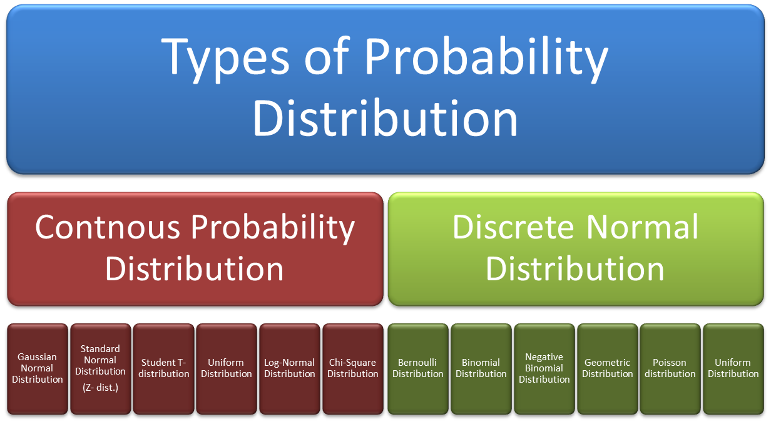

Normal distribution 🡪 and standard normal distributions (Z –score , z-table)